**Cloud flare:**

CloudFlare is more than a simple appliance filter, it protects and accelerates websites.

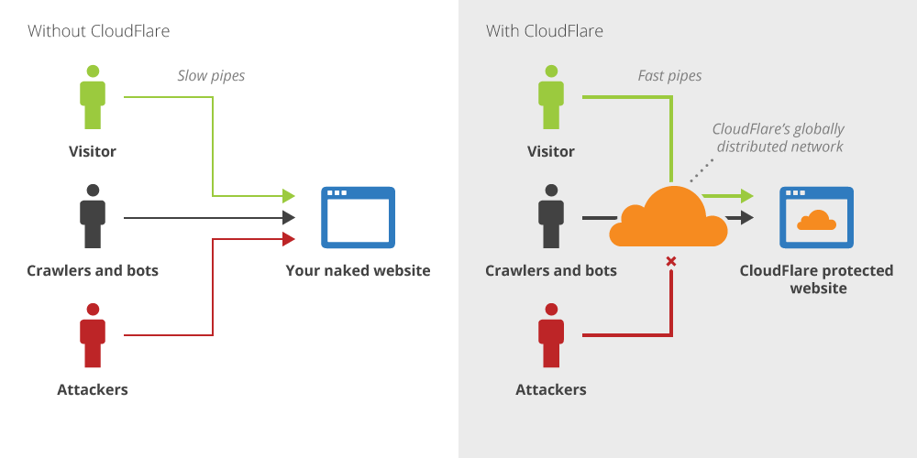The Cloudflare network is powered by 122 data centres around the world, more than 5 percent of global Web requests flow through Cloudflare’s network; every month more than 1.8 billion people experience a faster, safer, better Internet thanks to Cloudflare



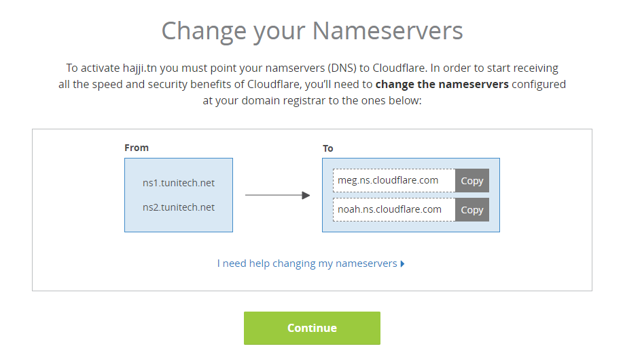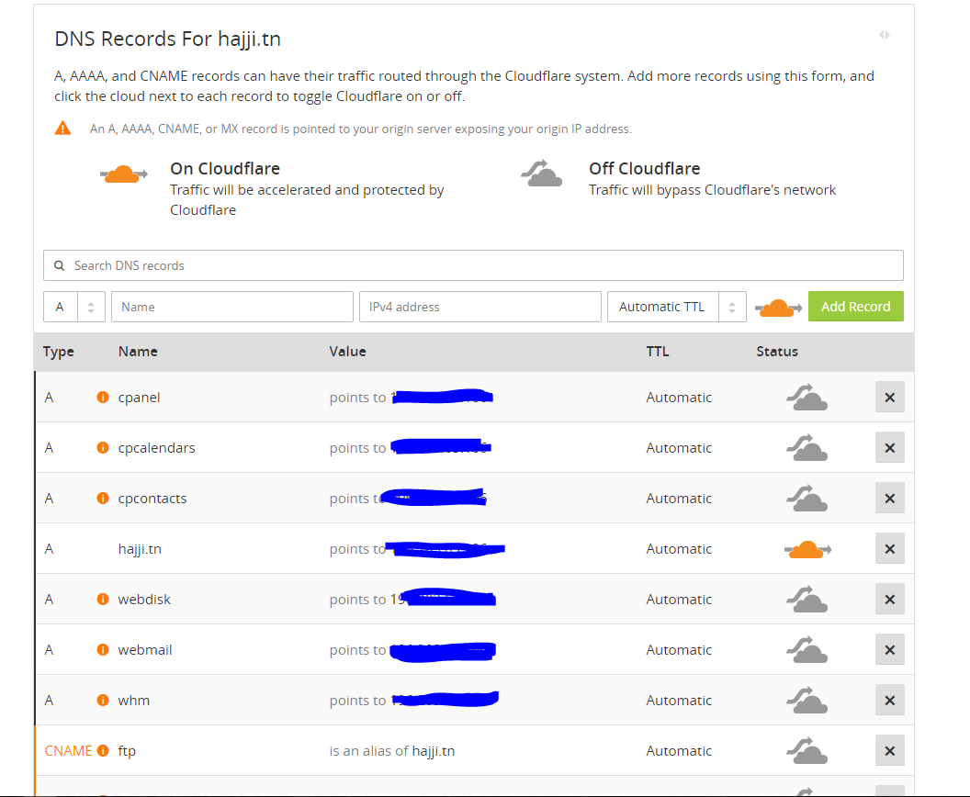The system works like a Content Delivery Network (CDN)

**Features:**

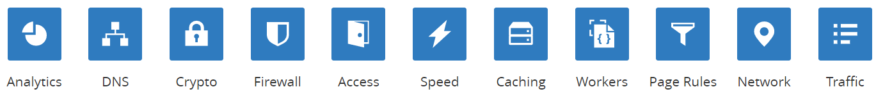

* **Analytics:**

View performance and security statistics

* **DNS:**

Manage Domaine name system

* **Crypto**:

Manage cryptography setting of the website

Redirection of all request HTTP to HTTPS

* **Firewall**

Manage access by IP, Country, or query rules

Web application Firewall

Browser integrity check

* **Speed**

Manage performance settings of the website

Auto Minify: Reduce the file size of source code on your website

Brotli: Speed up page load times for your visitor’s HTTPS traffic by applying Brotli compression.

* **Caching**

Manage Caching settings of the website

Always online: if our server is down, Cloudflare will serve our website’s static page from our cache.

**The configuration of the WAF:**

The Cloudflare WAF consists of three "Packages": Cloudflare Rulesets Package, OWASP Rulesets Package, and Custom User Rule Set:

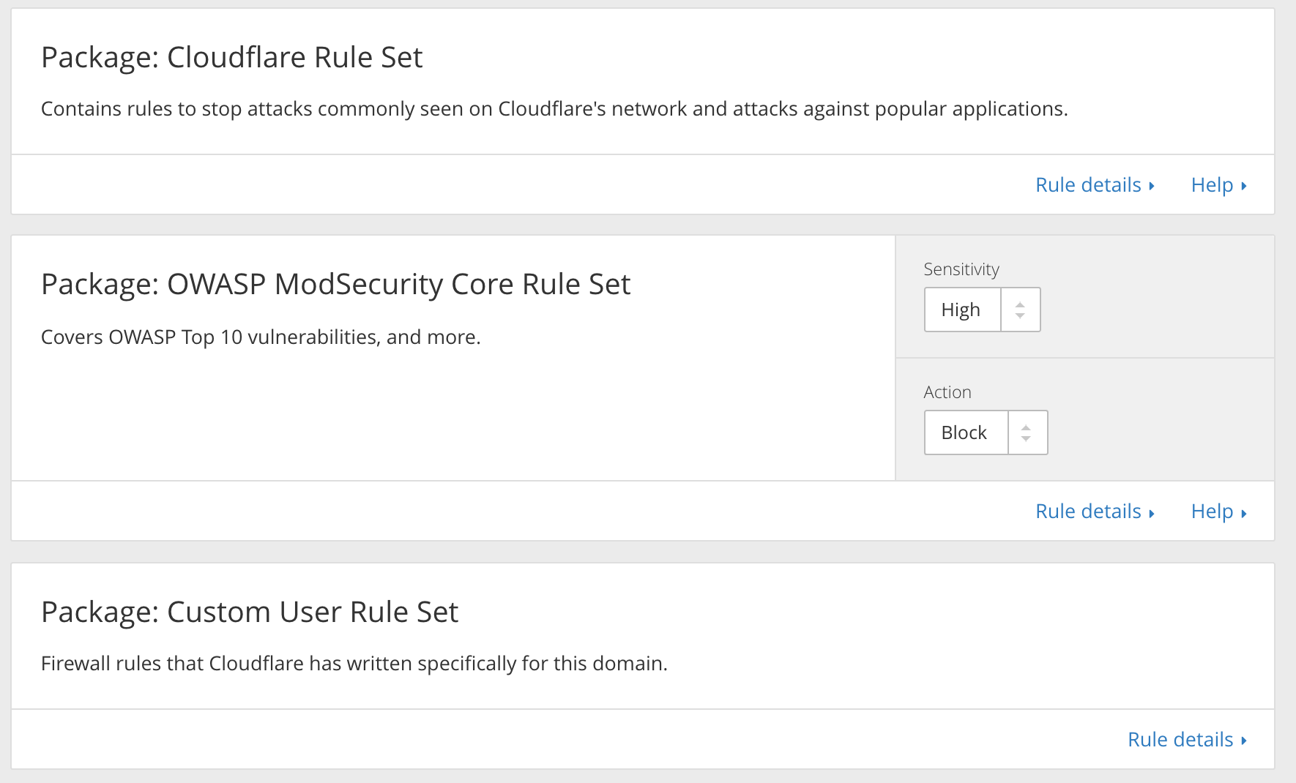

* **Cloudflare Rules:**

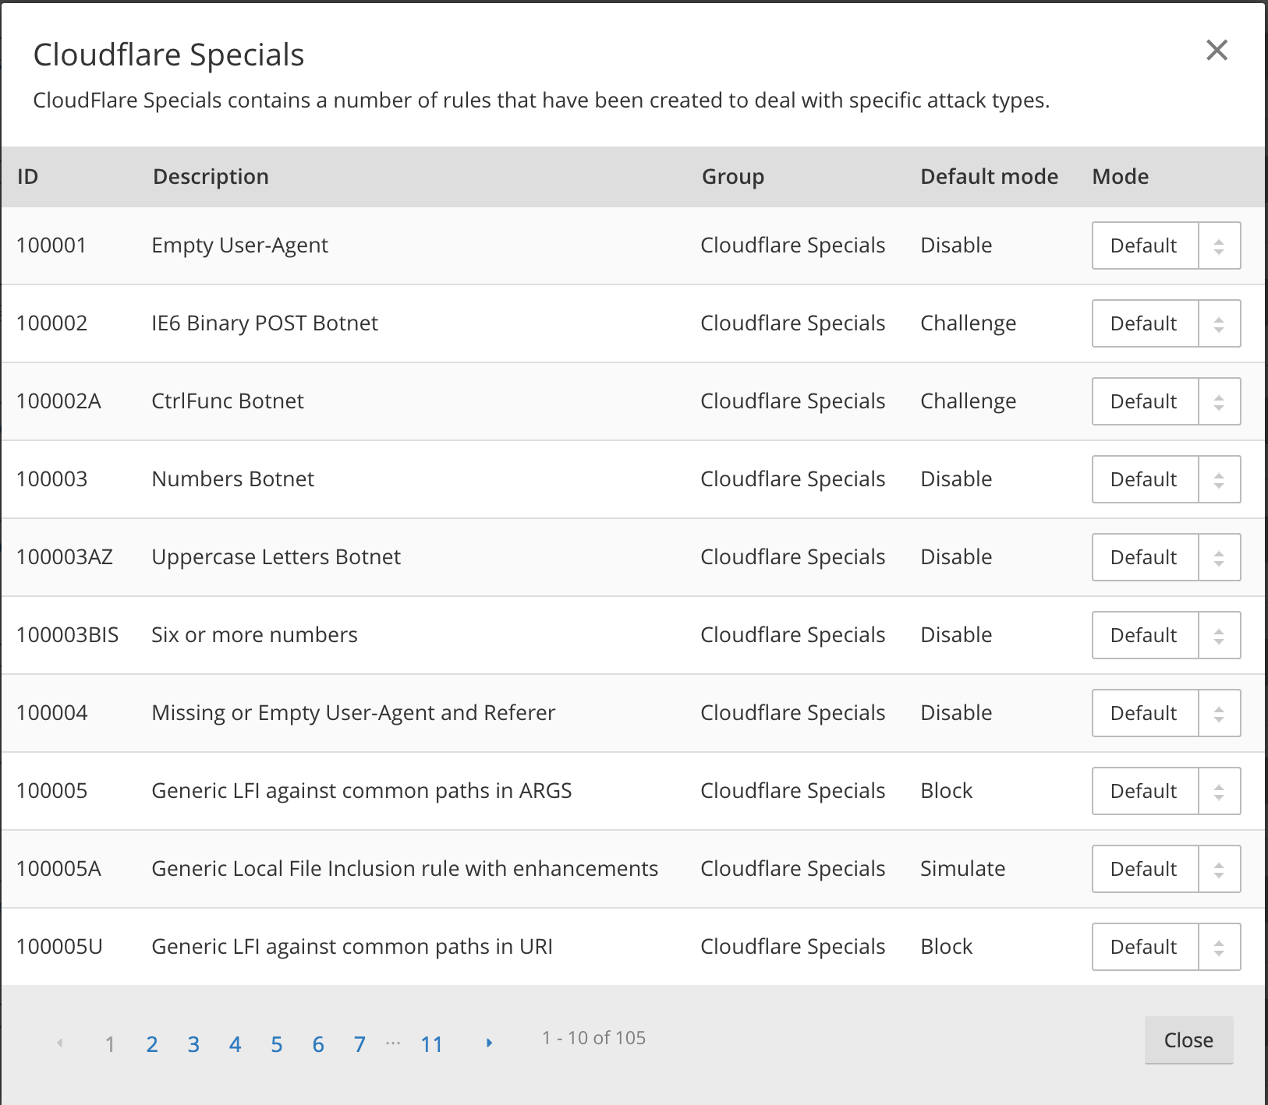These rules are written and created by Cloudflare Engineers.

* **OWAPS Rulesets Package:**

The OWASP Rulesets Package contains a number of rules from the [OWASP project](https://www.owasp.org/index.php/Category:OWASP_ModSecurity_Core_Rule_Set_Project).

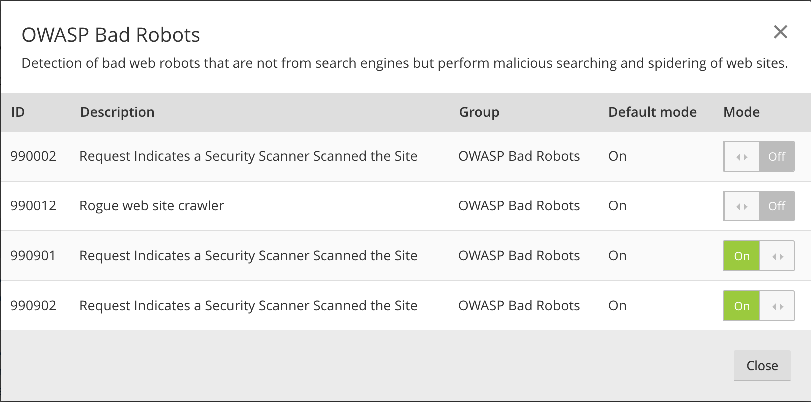

**Reviewing WAF log:**

Reviewing WAF logs can give you unique insight into our traffic and any potential malicious activity on our website. It can also enable us to optimize your WAF configuration.

